Week 14 HW – Spring Tutuorial

Leiland Tanner

Code: SEE ALSO MAVEN POJECT

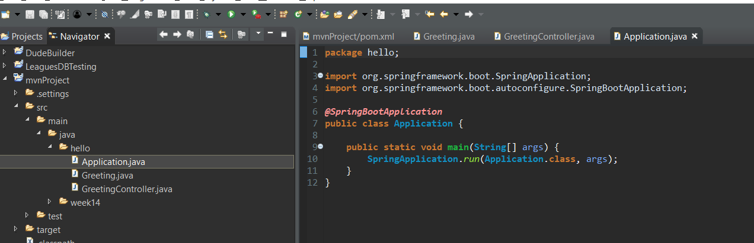

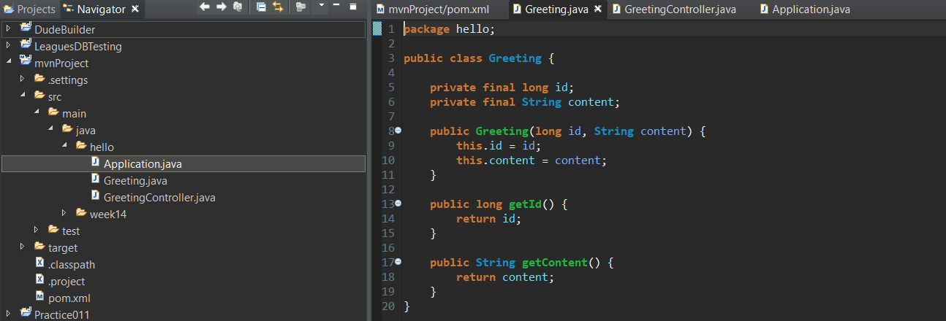

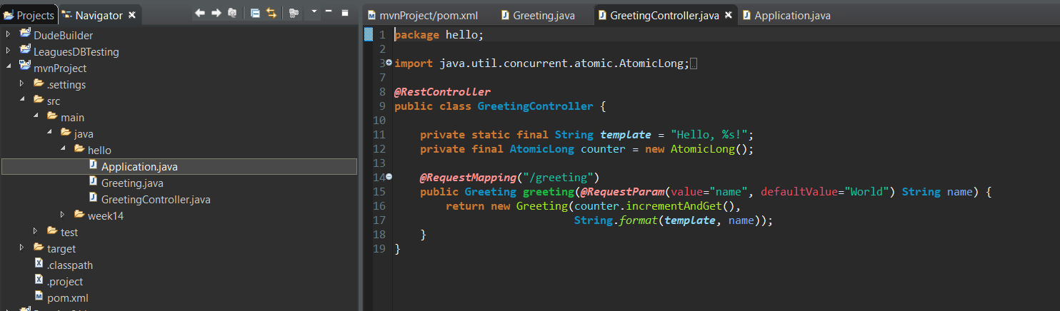

REQUEST TESTS:

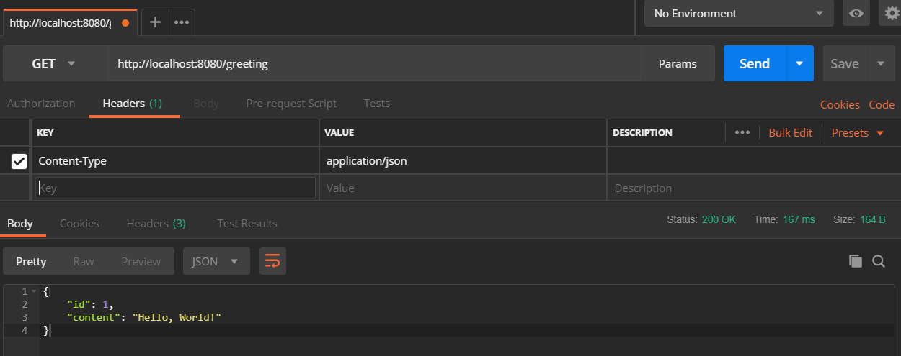

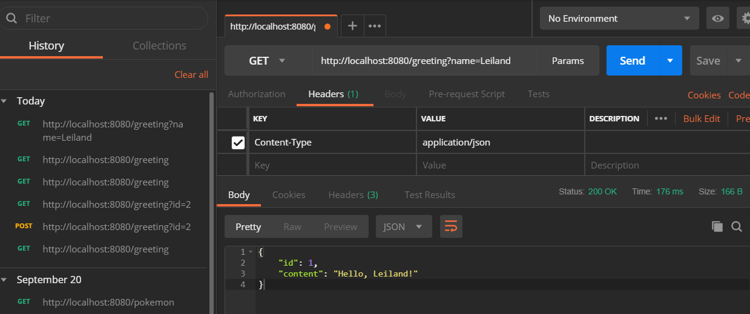

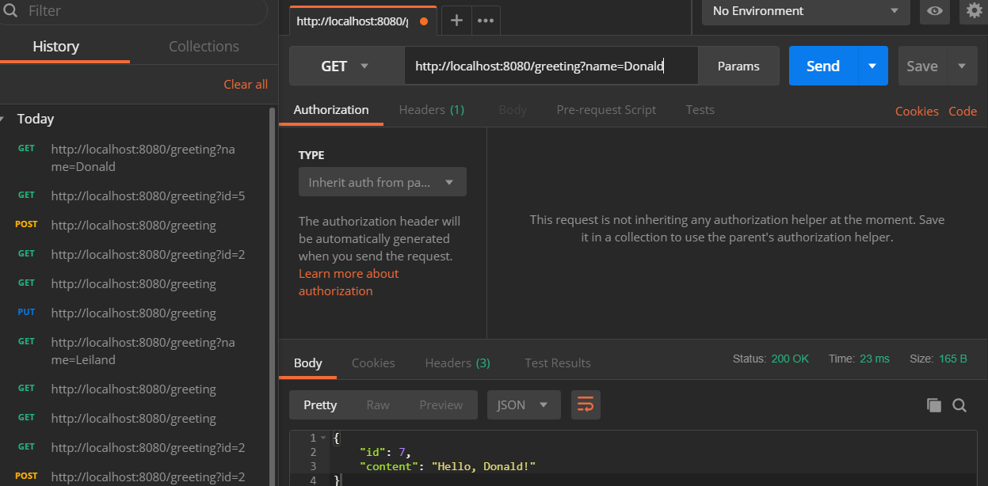

I had to go over the tutorial several times to understand the basic connection between the mvn project, spring boot and the spring framework. I also had to do a bit of google searching to overcome the definitions and gaps in relationships I wasn’t connecting. I also ran into the problem of not being able to send a valid PUT or POST request because there is no database connected to store the info on this tutorial. So I ended up just using the one changeable variable suggested by the tutorial to send 3 separate requests by changing the name parameter in the GET requests.

I learned a lot – fundamentally I learned that Spring boot is a full blown tool to manage these server requests on a mid or RESTful service level. I learned that that is an intermediary level of request handling between the user GUI and the mid level controllers and ultimately to the database. I will definitely need some practice and more familiarity but this definitely did the job introducing the concept and giving me some hands on experience.